CSULB — College of Engineering
Computer Engineering
Senior Design Project
CECS 490A
Author: Rodrigo Becerril Ferreyra
Teammates: Colton Curtis, Kevin Nguyen, Ethan Hua
Professor Dan Cregg
Table of Contents
Executive Summary 3
Responsibilities 4
Overall Progress Report 5
Concerns 5
Expected Final Grade 6

Executive Summary
Our project, which is called the Aftermarket Car Security System (ACSS), is an embedded system which has the ability to connect to the Internet and interact with the user. It uses a wide variety of sensors in order to correctly determine whether or not the user’s car has been damaged (e.g. door-dinged) or if any component of the car is being vandalized or stolen (for example, a tire or a catalytic converter). It communicates with the user’s smartphone using technologies such as SMS and the Cloud (Amazon Web Services). The ACSS sends live footage from its cameras to the user’s phone via a website. The user can then watch the live footage and decide whether or not the event was a false alarm; the ACSS can then be turned off remotely if necessary.
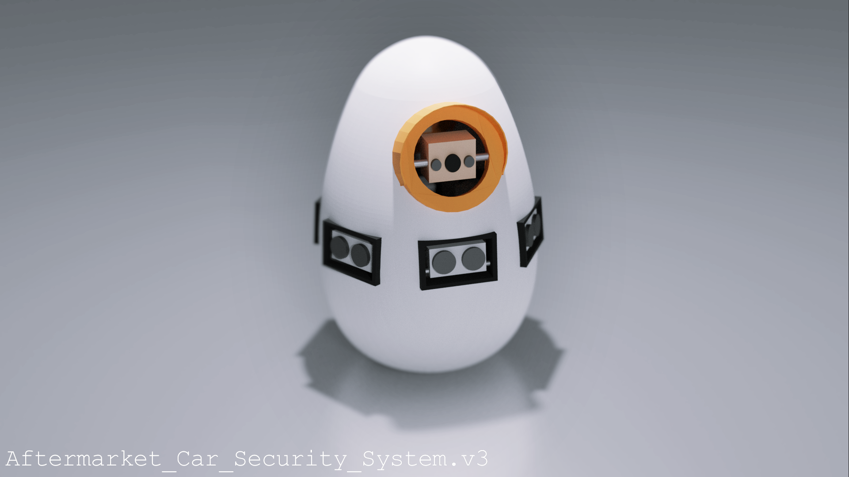Figure 1: A render of a 3D model of the ACSS. Model by Colton Curtis.

An important part of our project is response time: the user should be alerted of a possible incident within a reasonable amount of time. The system also begins to record information and send it to cloud services, allowing evidence to be collected for possible police filing.

Responsibilities
Since the beginning of this semester, I have assumed many different responsibilities. Since I was in charge of machine vision last semester, I took charge of other camera-related functions, namely livestreaming. Livestreaming is an essential part of our embedded system, since it gives the user a direct look at what is happening with his or her car. “Livestreaming” also includes figuring out how to record the video to a file directly, and how to upload that to a cloud storage service. I successfully implemented this by the first demo.
The second major responsibility I had was figuring out how to convert a microphone into an audio sensor. This means that instead of recording audio, I needed to figure out a way to detect the ambient volume of the embedded system’s surroundings. If the volume was too high, it might mean that someone was using an angle grinder on the car’s catalytic converter or something similar. I successfully implemented this by the second demo.
Something I am currently responsible for is detecting whether a Bluetooth Low Energy tag is detectable by the Raspberry Pi. This can be used to determine whether or not a component has stolen. I am currently working on implementing this by the third demo.

Overall Progress Report
I believe that our project is progressing very smoothly. We are on schedule with all our tasks, and are constantly thinking of ways to add to our system or removing planned features that may not perform the functions that we originally planned. An example of this is the fact that we decided to scrap the idea of using machine vision to determine whether or not there was a person present in an image. The reason for this is twofold: a) it took too long for the Raspberry Pi to calculate the math to produce a result from the machine vision algorithm, and b) the machine vision algorithm would completely miss events such as a catalytic converter being stolen (as that happens at the bottom of a car) and a door ding (as that happens without any humans visible).
As for the future, we have many things planned out in Tasks and each team member has a clear goal for the weeks to come. As of right now, I am in charge of two things: implementing the Bluetooth Low Energy tagging detection (which detects if a tag has been taken out of range) and helping with the website, including implementing a video player that can view our livestream data.

Concerns
Last semester, my greatest concern was cost. This semester, my greatest concern is time. Our team lost approximately two weeks at the beginning of the semester when the university failed its students in bringing them back on campus. We also lost approximately one week due to the power outage experience by the whole school one Tuesday night. My team and I are moving along at a decent pace, but these two events managed to push the three demos and the final project rather close together. Our team had to come up with solutions to these problems quickly, as our plans and project velocity were suddenly pushed forward a week or two.

Expected Final Grade
I expect to receive an A for this class. The purpose of this class, according to the CSULB catalog, is to “build, program and verify operation of project started in prior design course.” So far, we have significant progress in building, programming, and verifying the operation of ACSS, our embedded system that was designed last semester. The catalog also says that the team “must submit a written report, give an oral multimedia presentation and provide a working demonstration.” So far, we have submitted our midterm report, and given two oral presentations and working demonstrations (and we even got top three in presentation rankings on the first demo). For following and exceeding these course expectations, my team and I should receive at least a B.
The grade of an A implies going beyond the class requirements and completing all the work assigned. I believe we are going above and beyond this by gathering our knowledge of previous classes, and acquiring new knowledge not taught in our classes, and bringing them together in a product that could compete with other real security systems on the market today. For example, our team is implementing this projects in many different domains of computer science and computer engineering using technologies that we as a team have never learned before. This includes using building a website using React.js and Node.js. We are also learning to use the AWS stack and self-hosted solutions. It is for these reasons that I believe my team and I should all receive an A this semester.

